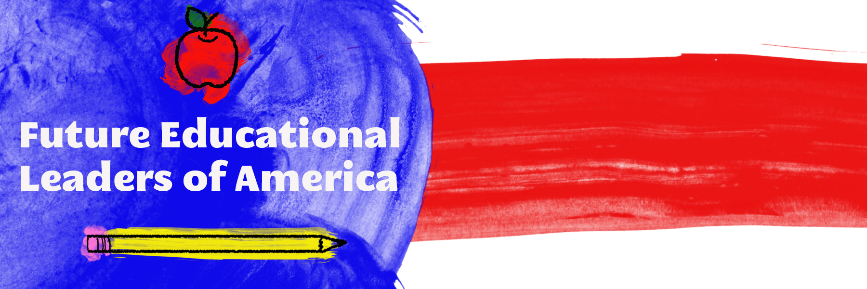
Statement of Purpose
FELA strives to promote the understanding of educational issues that are prevalent in today’s society, along with a developing base of knowledge about becoming an educational administrator and/or policy maker, and opportunities to network with professionals in the field. FELA is an open forum for students to voice their opinions about the current state of the education system of America.

